**Steps With Images**

Architecture To be Followed

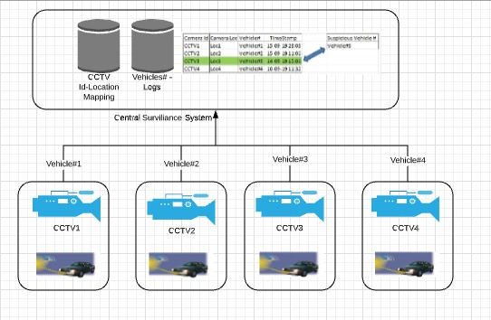



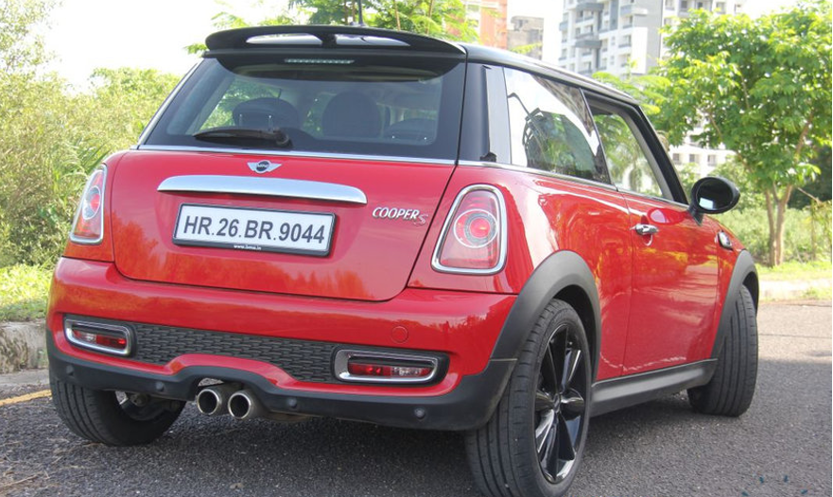

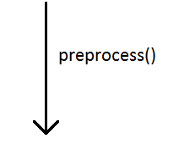



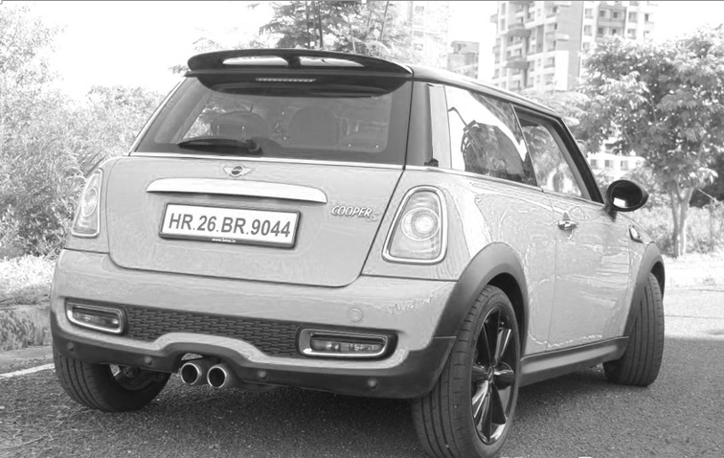

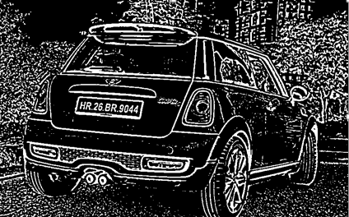

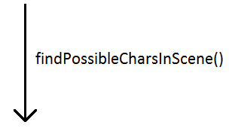

 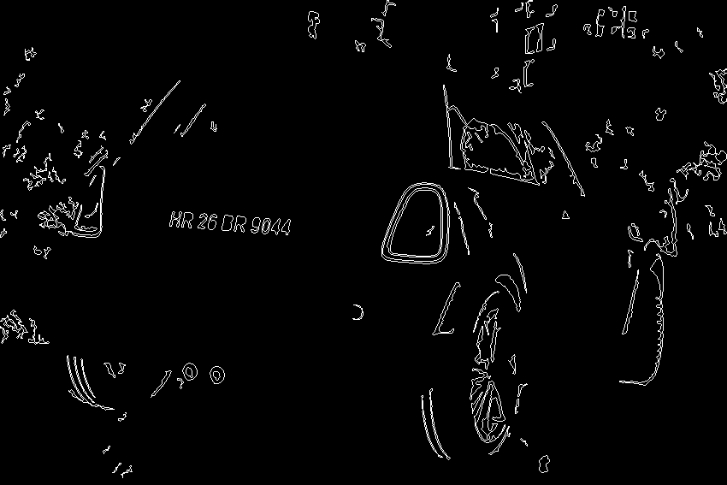

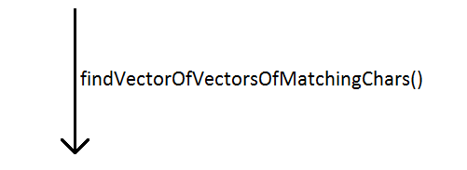



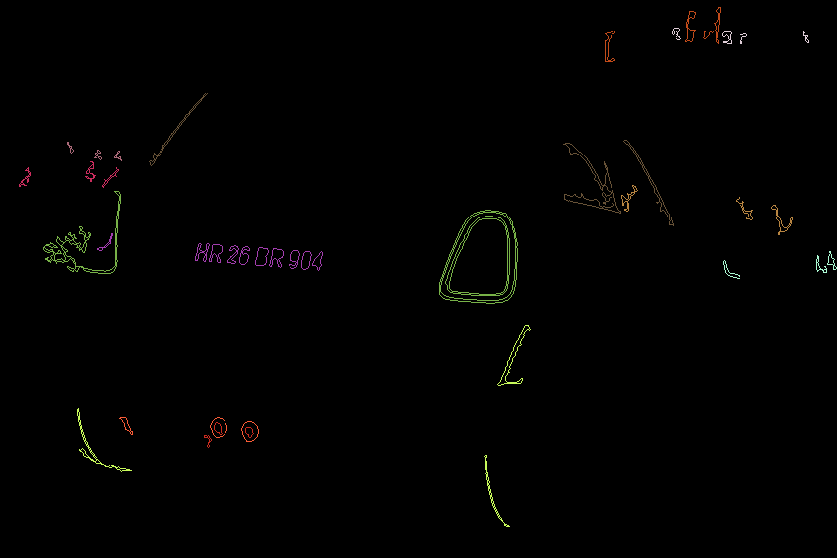

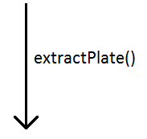



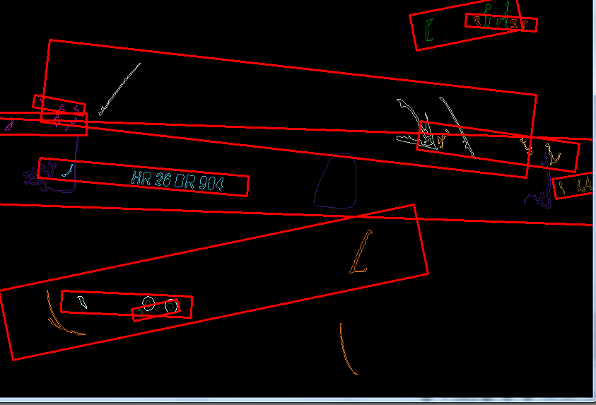

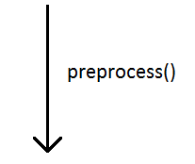



C:\Users\Nikhil\Downloads\Machine_Learning\OpenCV_3_License_Plate_Recognition_Python-master\OpenCV_3_License_Plate_Recognition_Python-master\OpenCV_3_License_Plate_Recognition_Python-master\IntermediateImgs\VehiclePlate.PNGPlate.png C:\Users\Nikhil\Downloads\Machine_Learning\OpenCV_3_License_Plate_Recognition_Python-master\OpenCV_3_License_Plate_Recognition_Python-master\OpenCV_3_License_Plate_Recognition_Python-master\IntermediateImgs\VehiclePlate.PNG5a.png

C:\Users\Nikhil\Downloads\Machine_Learning\OpenCV_3_License_Plate_Recognition_Python-master\OpenCV_3_License_Plate_Recognition_Python-master\OpenCV_3_License_Plate_Recognition_Python-master\IntermediateImgs\VehiclePlate.PNGThreshold.png C:\Users\Nikhil\Downloads\Machine_Learning\OpenCV_3_License_Plate_Recognition_Python-master\OpenCV_3_License_Plate_Recognition_Python-master\OpenCV_3_License_Plate_Recognition_Python-master\IntermediateImgs\VehiclePlate.PNG5b.png

 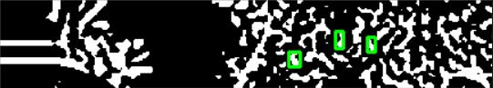

 

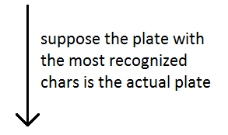

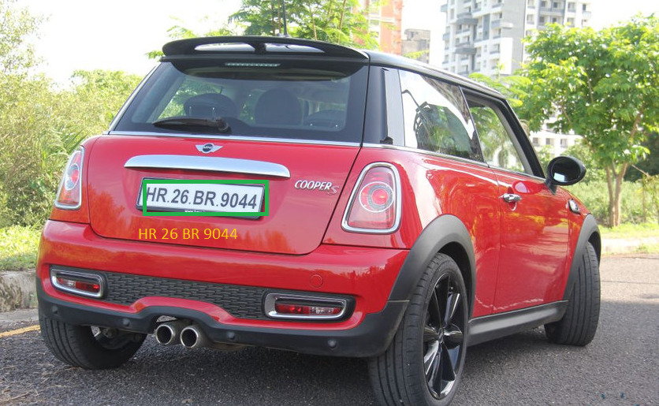

**Output:**

Output Log file which will be having Information about the suspicious vehicle number found by this Camera Id.

